Laboratorul 2

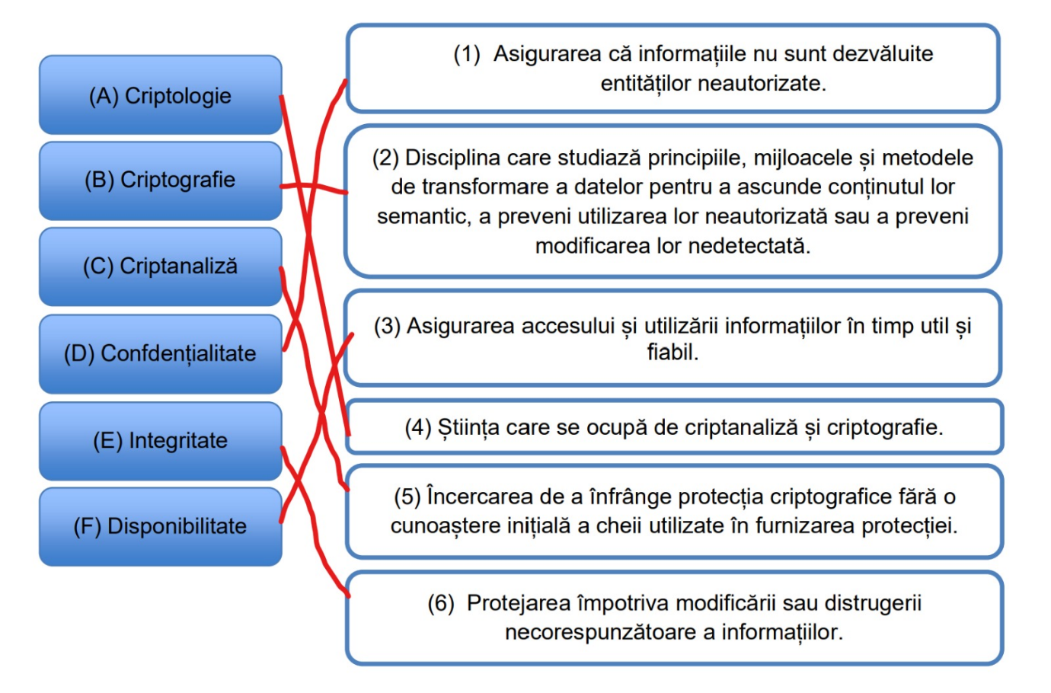
1.

2.
1. Salariile angajaților nu trebuie făcute publice. - CONFIDENTIALITATE
2. Biroul casierie trebuie să aibă acces la salariile angajaților (pentru a realiza plățile). - DISPONIBILITATE
3. Un angajat nu își poate modifica singur suma primită ca salariu pe luna în curs. - INTEGRITATE
4. Un angajat nu ar trebui să afle cât câștiga un coleg fără acordul acestuia (ex. să îi spună direct). - CONFIDENTIALITATE
5. Biroul casierie trebuie să aibă certitudinea că suma pe care o înmânează angajatului de plată este cea corectă. – INTEGRITATE
3.
Sistem cu metoda substitutiei: Caesar Cipher
Each letter in the plaintext is replaced by a letter some fixed number of positions along the alphabet.
Exemplu:
Criptare: MATEI = PDWHL, cu deplasare de 3 la dreapta: M+3=P, etc. Viceversa pentru decriptare.
Securitate: este foarte slab, poate fi spart prin brute-force.

Sistem cu metoda transpozitiei: Rail fence cipher
The plaintext is written downwards diagonally on successive "rails" of an imaginary fence, then moving up when the bottom rail is reached, down again when the top rail is reached, and so on until the whole plaintext is written out. The ciphertext is then read off in rows.
Exemplu:
Criptare: MATEI = MTI AE
M . T . I
. A . E .
Decriptare: punem literele fiecarui cuvant cu 2*(n-1) spatii intre ele, unde n este numarul de cuvinte, apoi citim \/\/\ .
Securitate: este foarte slab, poate fi spart prin brute-force.

4.
ALICE AND BOB ARE THE WORLDS MOST FAMOUS CRYPTOGRAPHIC COUPLE. SINCE THEIR INVENTION IN 1978, THEY HAVE AT ONCE BEEN CALLED INSEPARABLE, AND HAVE BEEN THE SUBJECT OF NUMEROUS DIVORCES, TRAVELS, AND TORMENTS. IN THE ENSUING YEARS, OTHER CHARACTERS HAVE JOINED THEIR CRYPTOGRAPHIC FAMILY. THERES EVE, THE PASSIVE AND SUBMISSIVE EAVESDROPPER, MALLORY THE MALICIOUS ATTACKER, AND TRENT, TRUSTED BY ALL, JUST TO NAME A FEW. WHILE ALICE, BOB, AND THEIR EXTENDED FAMILY WERE ORIGINALLY USED TO EXPLAIN HOW PUBLIC KEY CRYPTOGRAPHY WORKS, THEY HAVE SINCE BECOME WIDELY USED ACROSS OTHER SCIENCE AND ENGINEERING DOMAINS. THEIR INFLUENCE CONTINUES TO GROW OUTSIDE OF ACADEMIA AS WELL: ALICE AND BOB ARE NOW A PART OF GEEK LORE, AND SUBJECT TO NARRATIVES AND VISUAL DEPICTIONS THAT COMBINE PEDAGOGY WITH IN-JOKES, OFTEN REFLECTING OF THE SEXIST AND HETERONORMATIVE ENVIRONMENTS IN WHICH THEY WERE BORN AND CONTINUE TO BE USED. MORE THAN JUST THE WORLDS MOST FAMOUS CRYPTOGRAPHIC COUPLE, ALICE AND BOB HAVE BECOME AN ARCHETYPE OF DIGITAL EXCHANGE, AND A LENS THROUGH WHICH TO VIEW BROADER DIGITAL CULTURE. X.DUPONT AND A.CATTAPAN CRYPTOCOUPLE
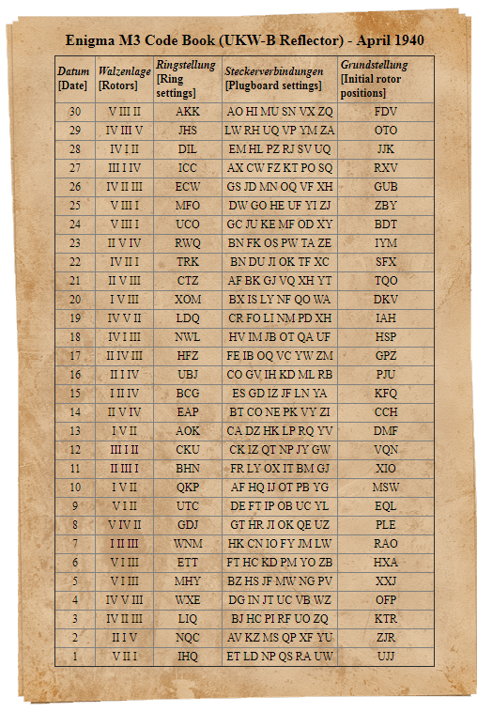
5.
Am vizualizat video-ul.
Data de azi: 12 martie, deci am ales 12 din tabel.

Un cod care nu ar putea cripta numele meu este ceva ce
Incepe cu M, deoarece o litera nu poate fi criptata in ea
Insasi.

